Routing in Wormhole-Switched Clustered Networks with Applications to Fault Tolerance
Vivek Halwan, Member, IEEE, Füsun Özgüner, Member, IEEE, and Atakan Dogan
IEEE Transactions on Parallel and Distributed Systems, Vol. 10, No. 10, pp. 1001-1011 Oct. 1999
Abstract
This paper presents a novel technique for routing in wormhole-switched multiprocessor interconnection networks with clustered configuration. The network model used here consists of a set of clusters interfaced through a common central network.
- Introduction
- Routing in Wormhole-Switched Clustered Networks
2.1 The Clustered Network Model
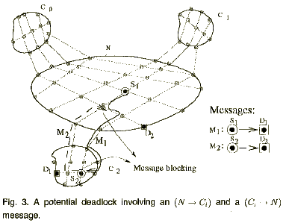
  - A Global Routing Method
For a deadlock-free implementation of R_{G}, using two virtual channel sets, vc₀ and vc₁, for each physical channel in a cluster Ci.
- Fault-Tolerant Routing Based on The Clustered Network Model
Block-fault model
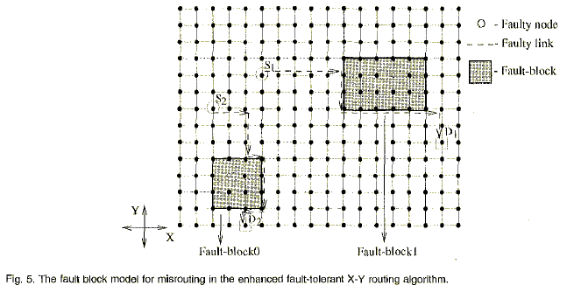
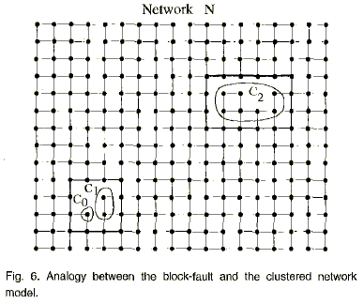
A Modified Block-Fault Model for a Simplified Implementation of R_{F}
Two-level block-fault model
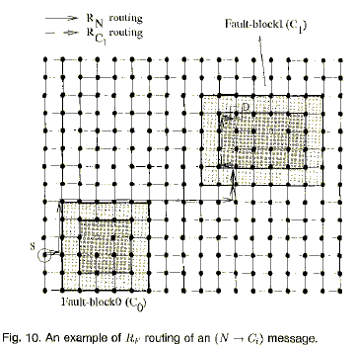
- Simulation Results
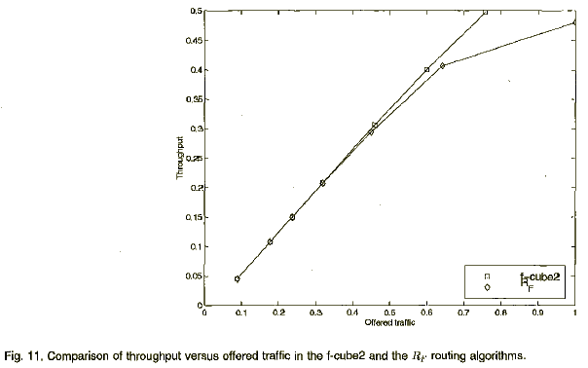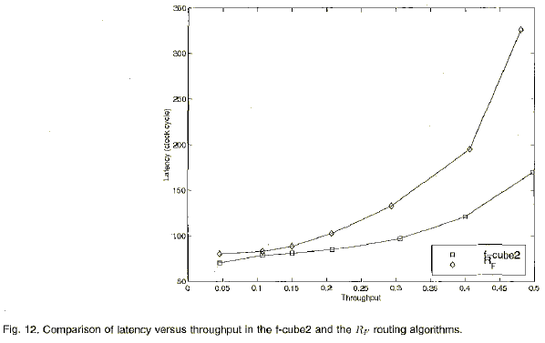
- Conclusion
Created by : Ming-Cheng Lin
Date : Mar 14, 2000

